DC motor:
A direct current (DC) motor is widlely controlled by a microcontroller. This motor moves in one direction by connecting a dc power supply to + and – leads. Change of this leads, changes the direction of movement.

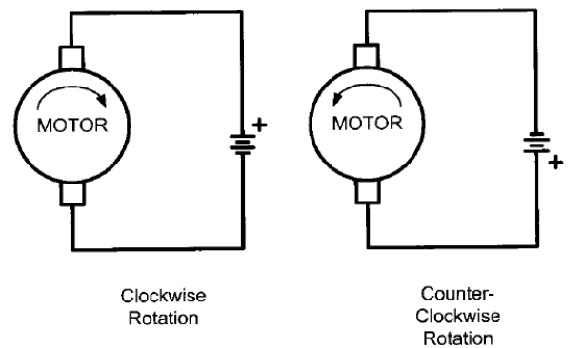
Driving a DC motor by a transistor or Mosfet.

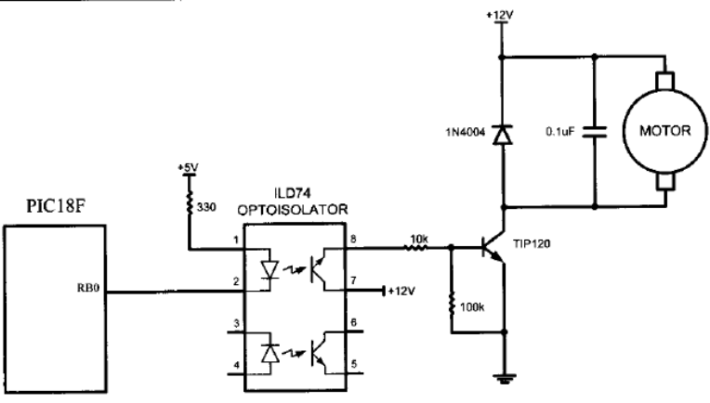
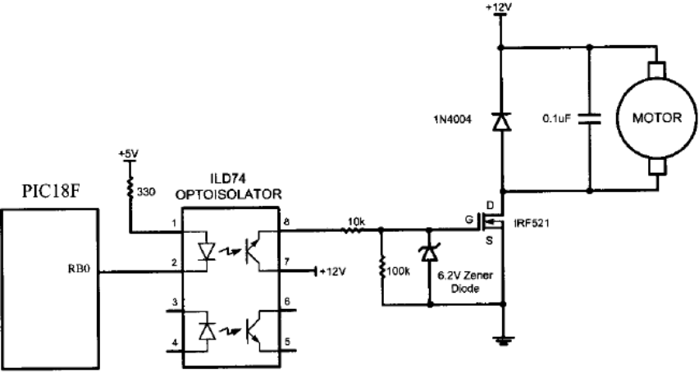
OR→

Appication example: DC motor control using PWM
The speed of a permanent magnet motor depends on the current through the armature coil. With the a field coil motor the speed can be changed by varying the armature current. Thus speed control can be obtained by controlling the voltage applied to the armature. Because of fixed voltage supplies, often we need an electronic circuit to regulate the voltage supply for speed control. The most common technique known as Pulse Width Modulation (PWM) is used. The technique involves generating a square wave or simply chopping off the constant dc supply, so that the average value is changed. The PWM can be obtained by means of a basic transistor circuit. The base voltage is switched on and off to obtain the necessary PWM duty cycle.
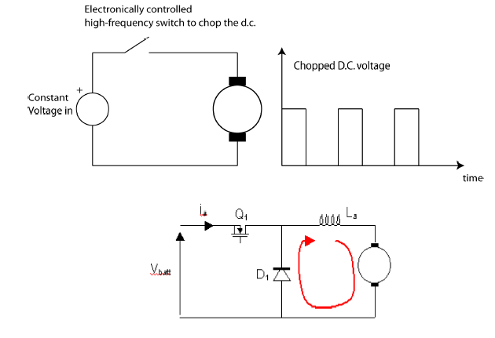

.

When the MOSFET (Q1) is on, current flows through the field and armature windings, and the motor rotates, When Q1 is turned off, the current flows through the inductor cannot immediately turn off, and so the inductor voltage drives a diminishing current in the same direction, which will now flow through the armature and back through D1 as shown in the figure 1. If D1 isn’t in place, a very large voltage will build up across Q1 and blow it up.
The diode is provided to avoid motor acting as a generator at the switching instance. Usually in microcontroller the PWM outputs are generated at a lower power level and requires additional circuit to supply power for a dc motor. In addition to the speed control we often requires to control the direction of rotations as well. To provide this interface a H circuit is often used, or called as H-bridge circuit.
Using forward diode (Snubber diode)
The parallel diode, known as a snubber diode protects against voltage spikes that are induced if the motor continues to spin due to inertia after the Mos-Fet is turned off.
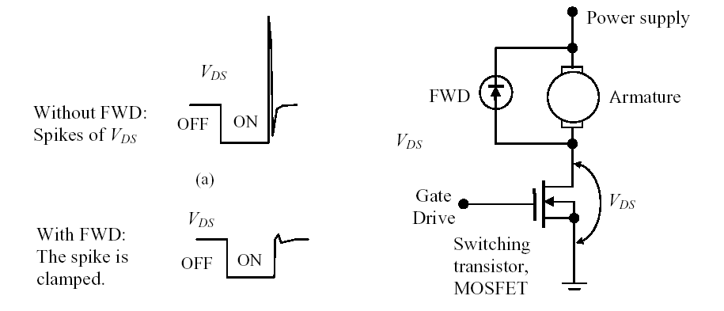
Generation of A PWM pulse without using a PWM module: (Mnual method)

Refer to figure , write a program with this condition:
If D.7 is 1 the DC motor moves with 25% duty cycle pulse.

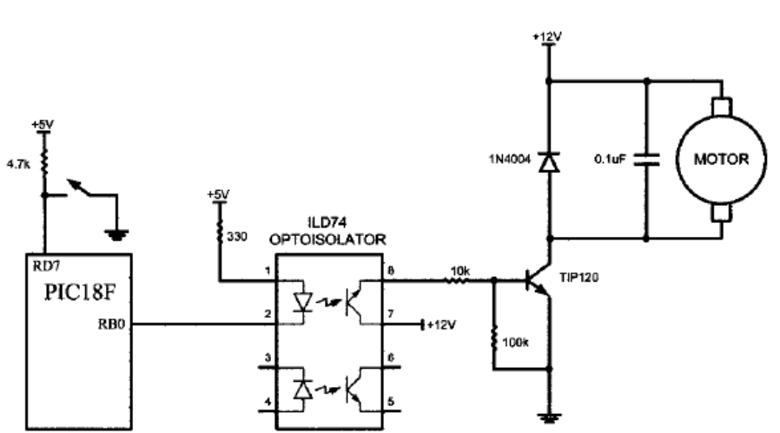

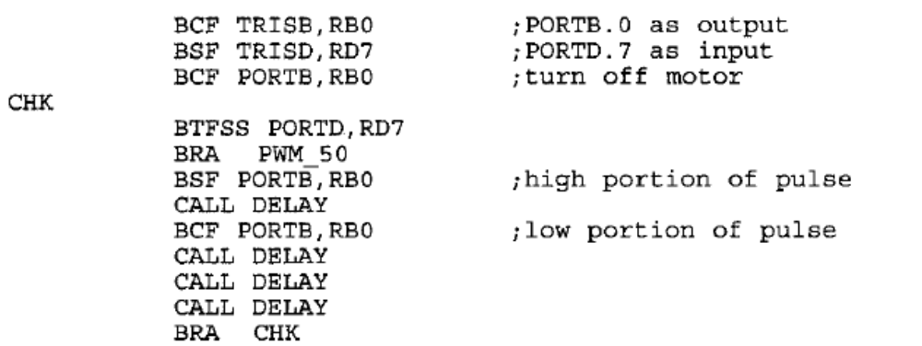

Not: In order to control motor speed by using PWM module , the output of PWM module or CCP module is sent to optoisolator.

Bidirectional DC motor control:
With the help of the relays or electronic swithes, we can change direction of dc motor rotation. Different direction of motor movement is shown in figures.

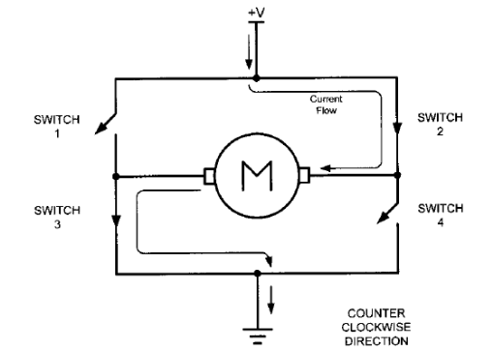
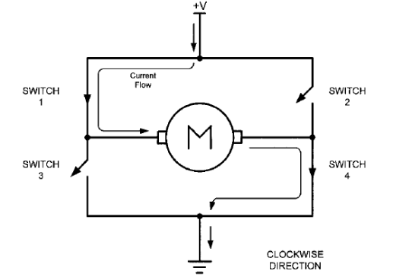

Table shows some of the logic configurations fort he Half bridge design.

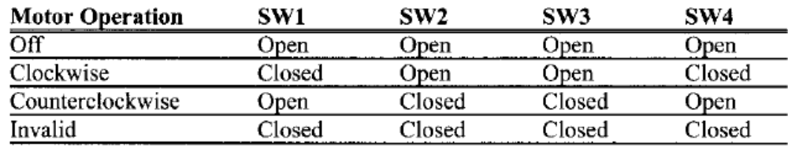

The full bridge circuit (two direction bipolar motor control)
The full bridge circuit is shown in Figure 4,5 below. Each side of the motor could be connected to either to battery positive or battery negative. To make the motor go forward, Q4 is turned on, and Q1 has the PWM signal. The current path is shown below. Note that there is also a diode connected in reverse across the field windings. This is to take the current in the field winding when all four switches in the bridge are turned off. Q4 is kept on so when the PWM signal is off, current can continue to flow around the bottom loop through Q3's parallel diode. Similarly to make the motor go backward, Q3 is turned on, and Q2 has the PWM signal applied to it.
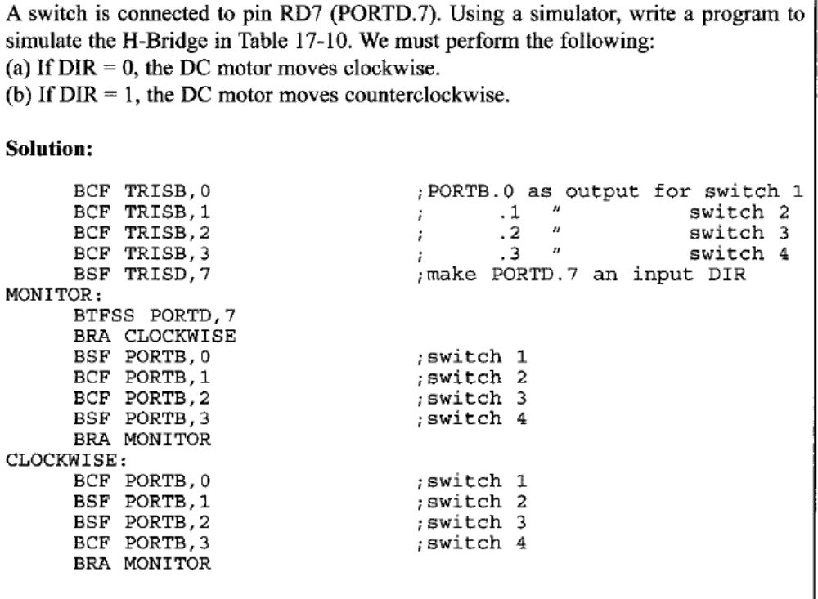

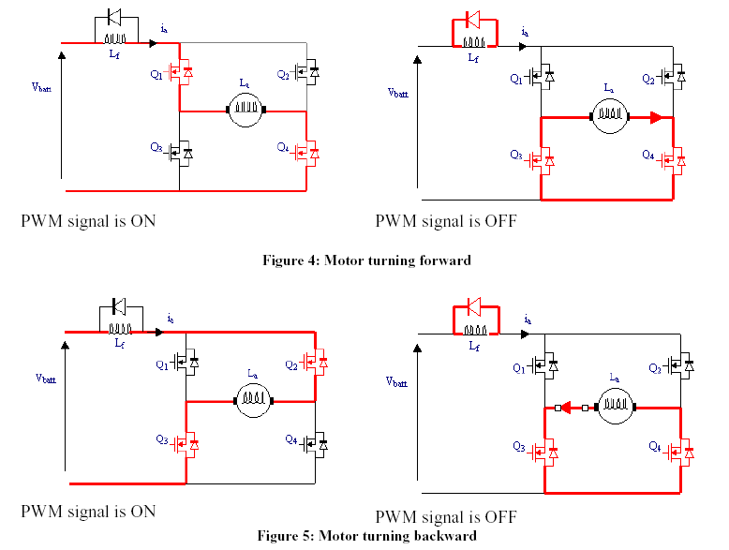
Circuit diagram of bipolar dc motor controller:When control input is low or high Q2-Q5 orQ3-Q4 are ON and motor can rotate in two direction. For opto-izolator are use for isolation of motor and control circuit.
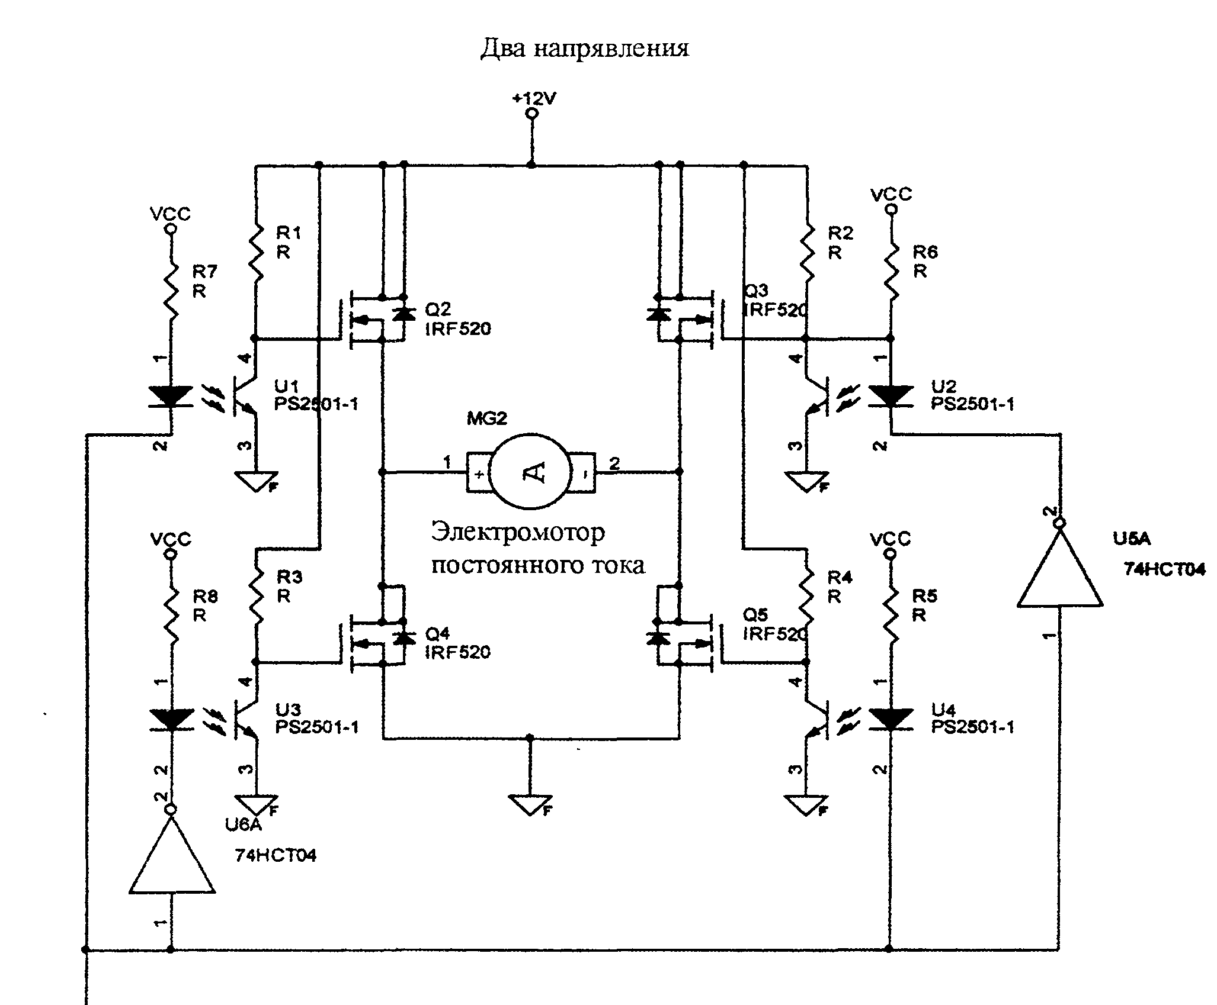
Bidirectional DC motor control using LM293 motor driver: (Add a switch top in RD7 as input
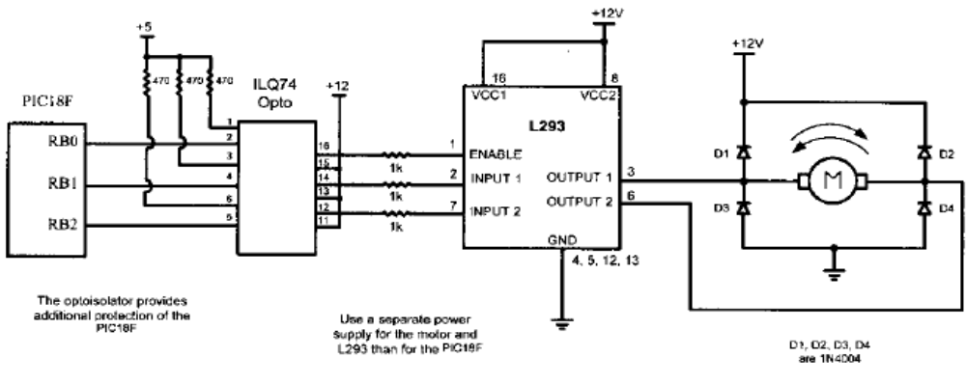

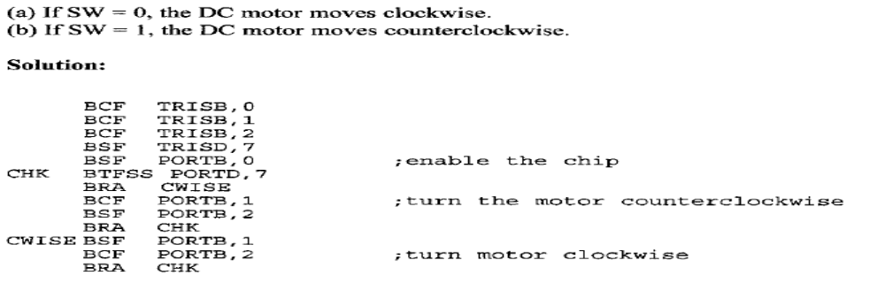
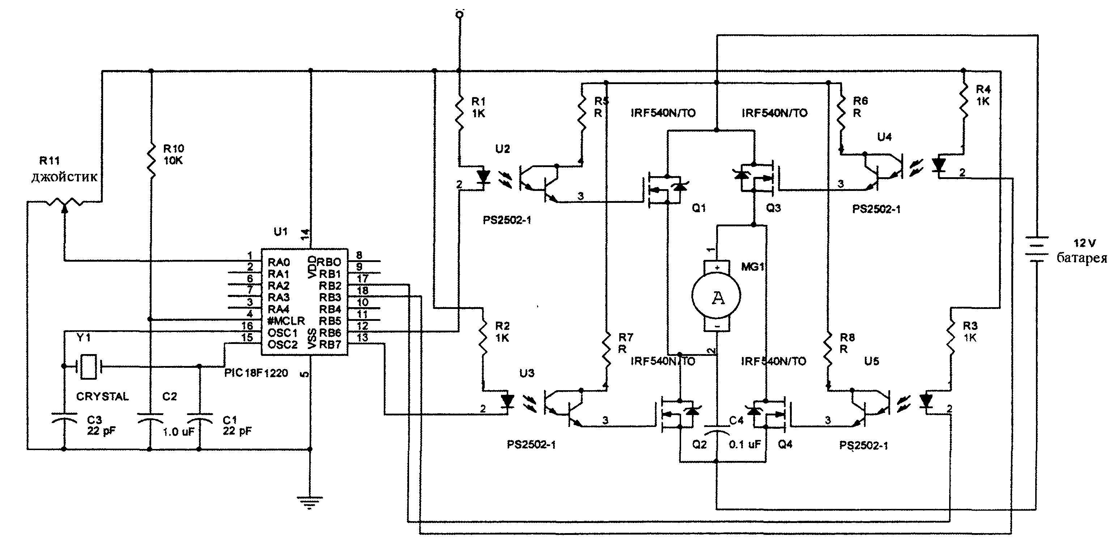
Jostick controlled DC motor
DC motor control: (speed- Torque- Position)
Each of these control types needs a sensor for feedback control. Motor speed control needs a tachometer (converts mechanical speed to voltage or shaft encoder (converts mechanical speed to digital puses). Motor torque control needs a current sensor, which converts motor current to a voltage.Motor position control needs a optical encoder or potentiometer which converts motor shaft position to digital pulses or analog voltage. A block diagram of motor speed control circuit is shown in figure.
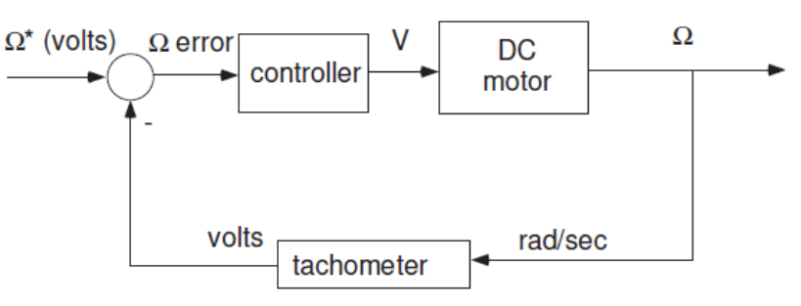
A motor speed feedback controller block diagram

